[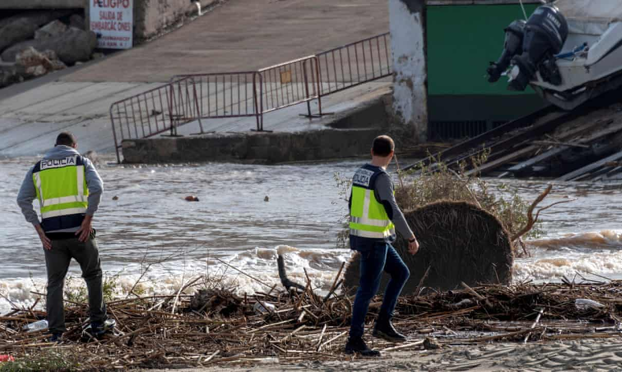](https://www.theguardian.com/world/2018/oct/10/uk-couple-reportedly-killed-mallorca-spain-flooding#img-1)