[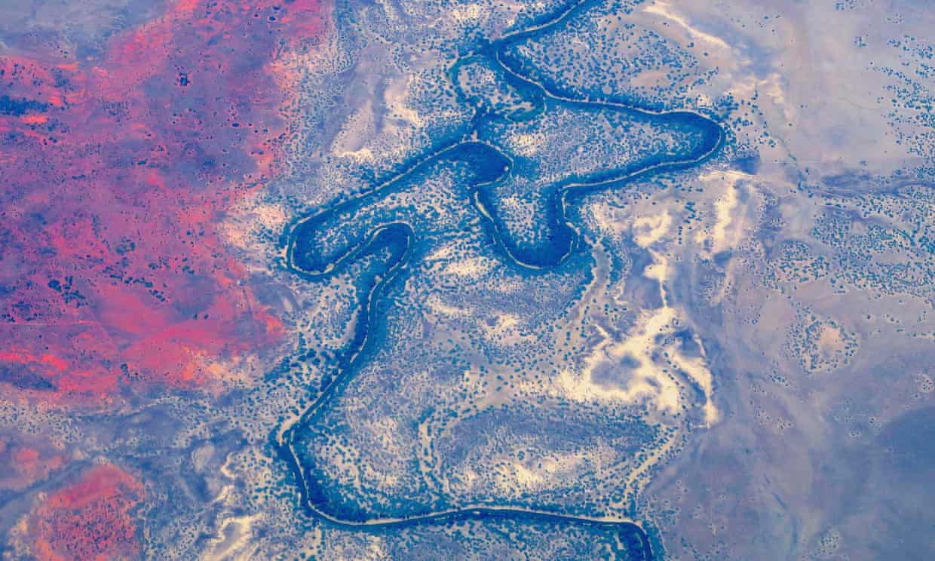](https://www.theguardian.com/australia-news/2018/sep/30/dumping-15m-tonnes-of-salt-at-queensland-creek-considerable-risk-to-water#img-1)

